**Karachi:**

Jinnah Mousoleum

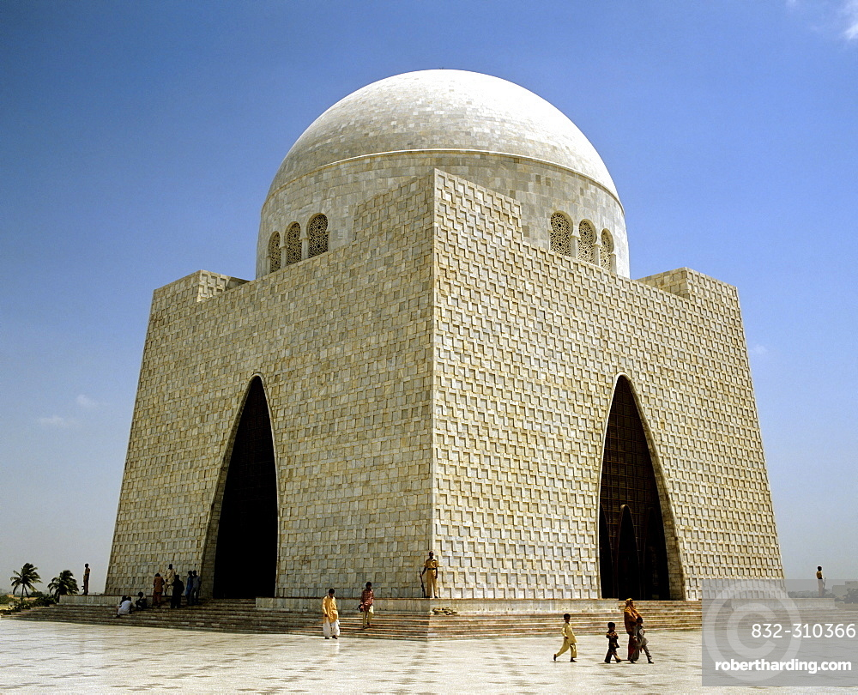

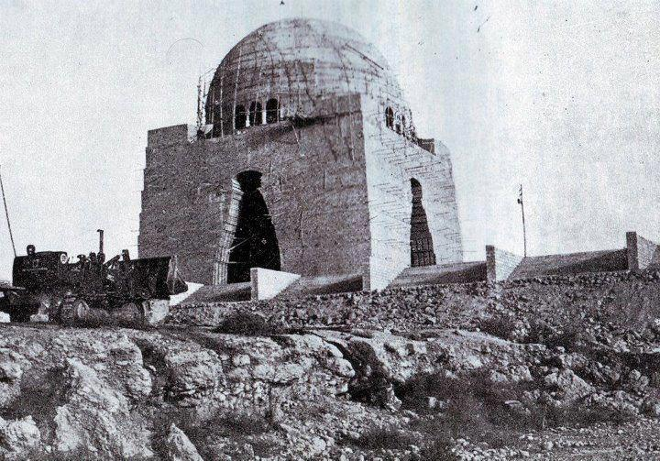

**Mazar-e-Quaid** also known as the **Jinnah Mausoleum** or the **National Mausoleum**, is the final resting place of Quaid-e-Azam ("Great Leader") Muhammad Ali Jinnah, the founder of Pakistan. Designed in a 1960s modernist style, the mausoleum also contains the tomb of his sister,Māder-e Millat ("Mother of the Nation") Fatima Jinnah, and that of Liaquat Ali Khan, the first Prime Minister of Pakistan.

Mohatta Palace

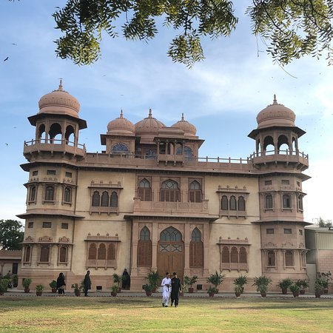

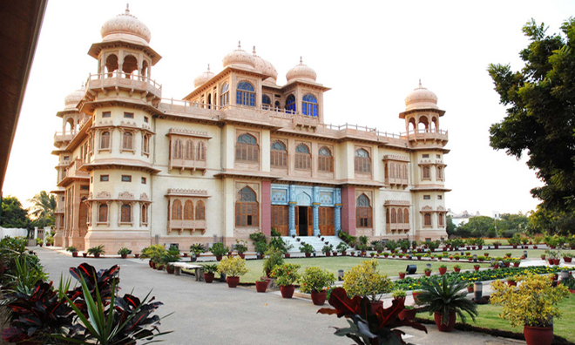

The **Mohatta Palace** is a museum located in Karachi ,Sindh, Pakistan. It was built in the posh seaside locale of Clifton by Shivratan Chandraratan Mohatta, a Hindu Marwari businessman from modern day Rajasthan in India, in 1927, as his summer home. The architect of the palace was Agha Ahmed Hussain. However, Mohatta could enjoy this building for only about two decades before independence, after which he left Karachi for India. He built the Palace in the tradition of stone palaces in Rajasthan, using pink Jodhpur stone in combination with the local yellow stone from Gizri. The amalgam gave the palace a distinctive presence in an elegant neighbourhood, characterised by Indo-Saracenic architecture which was located not far from the sea.

Clifton Beach

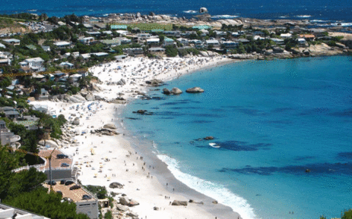

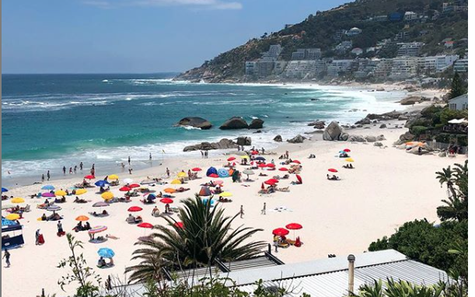

**Clifton Beach** or most commonly known as **Seaview** in Karachi, Sindh, Pakistan located on the Arabian Sea. It stretches from Karachi to Ormara (Balochistan). In 2003 it was affected by an oil spill and polluted with oil. In late 20th century, this beach was rated among most popular and top silver sand beach, but it was affected from oil spill in 2003. A wreckage and cargo of dhow caused the oil spill in the beach and polluted the beach , although the crew members of the wrecked dhow were rescued by Maritime Security Agency. The beach was closed for three days for removal of hay bales and cargo wreckage in the water.

Churna Island

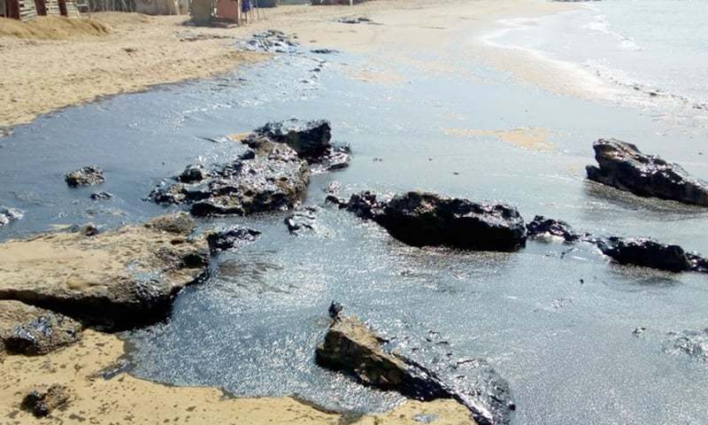

**Charna Island**( جزیرہ چرنا )is located near Mubarak Goth, Kiamari Town in Karachi, Sindh, Pakistan. Churna Island is a small uninhabited island located in the Arabian Sea, about 9km (5.6mi) west of the mouth of the Hub river called "Manjhar Beach", at the boundary between the provinces of Balochistan and Sindh. Charna is approximately 1.2km (0.75mi) long and 0.5km (0.31mi) wide. Charna is also locally known "Cheerno" and "Charna". It is 6km away from Mubarak Village. In winters (September to April) Local and foreigner tourist use to visit for adventure activities like Snorkeling, Cliff Diving, Scuba Diving, Spearfishing, Fishing Underwater photography with tour operator. Fishermen of Mubarak Goth go for fishing near the Charna Island. There are many species of fish, crabs and lobsters. Anglers take boats to go Island from Mubarak Goth. Mubarak Goth is a second largest fishermen locality in Karachi, which lacks facilities including education, health, jetty, ownership rights and communication etc.

# PAF Museum

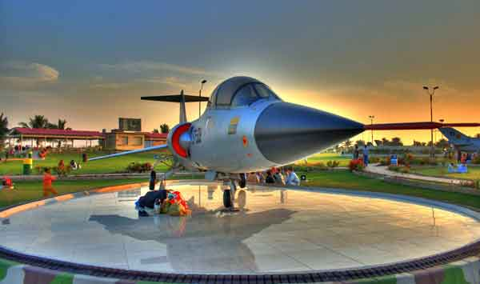

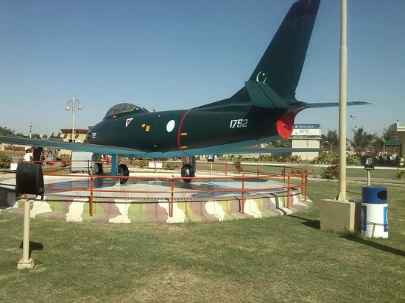

**PAF Museum, Karachi** is an Air Force museum and park situated near Karsaz Flyover on Shahrah-e-Faisal in Karachi,Sindh, Pakistan.A majority of the aircraft, weapons and radar are displayed outside in the park but the main museum features all major fighter aircraft that have been used by the Pakistan Air Force. The museum also houses the Vickers VC.1 Viking aircraft used by Mohammed Ali Jinnah, founder of Pakistan, and a Folland Gnat of the Indian Air Force, that landed in Pasrur town, Pakistan in the Indo-Pakistani war of 1965. Also on display are the scale models of some World War I, World War II and some more modern aircraft and photo galleries of almost all the squadrons of Pakistan Air Force.

Hawk's Bay

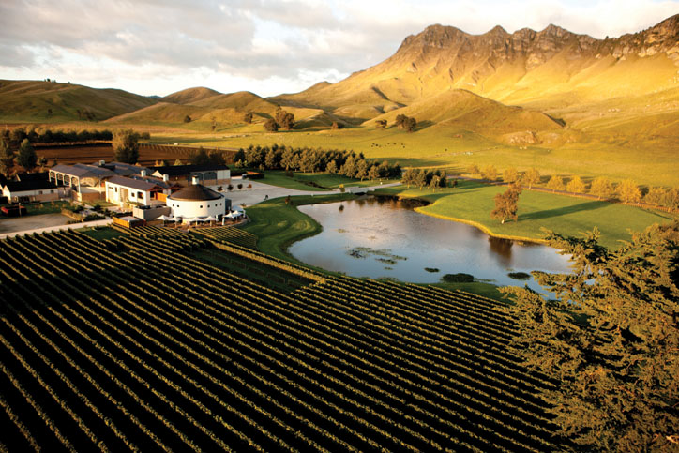

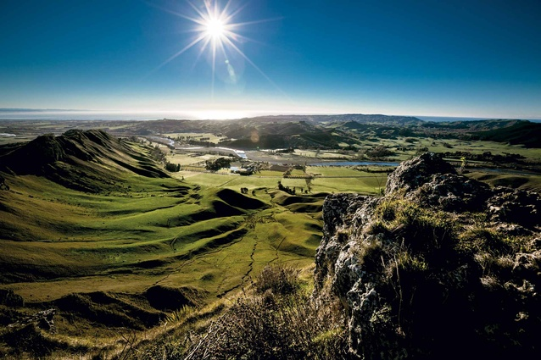

**Hawke's Bay** Or **Hawkesbay** is a beach in Karachi, Sindh, Pakistan located 20km at south-west of Karachi. This beach is named after Bladen Wilmer Hawke, who owned a beach house here in 1930s. Hundreds of people visit here daily for swimming, camel and horse riding and for vacations.